Lior Naar - 302820667

Eran Keren – 200839710

C:\Users\איתי\Downloads\class diagram.pngClass Diagram

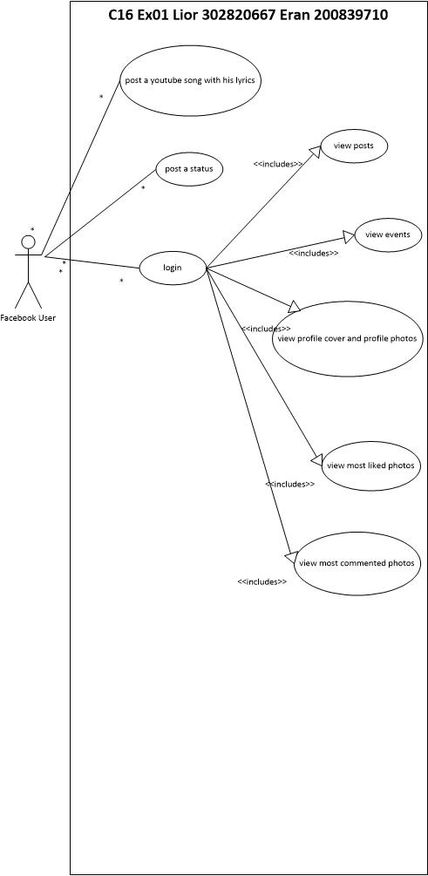Use Case Diagram

Feature sequence diagram 1:

Post song + song lyrics:

C:\Users\איתי\Downloads\Untitled Diagram (1).pngThis feature using a Web Service called LyricsWikia and when a user enters a name of an artist with song title and a url for a video, the App post the song with the song lyrics on his facebook wall

Feature 2:

Display the most commented photo and most liked photo for the user

C:\Users\איתי\Downloads\Untitled Diagram (2).pngSequence diagram